Table of Contents
Bibliography 37
References 37

Introduction
Global maritime trade is the foundation of the international economy, accounting for some 80% of global trade by volume. Strait of Hormuz is one of a number of strategic maritime chokepoints, critical nodes that transport massive quantities of energy, commodities and goods through and are therefore particularly exposed to geopolitical disorder ( Lumma, Verschuur, & Hall, 2026).
The Bay of Hormuz, linking the Persian Gulf with the Gulf of Oman, is one of the world’s most important oil transit chokepoints. It carries about one-fifth to one-quarter of the world’s seaborne oil trade (about 20 million barrels per day in recent years), and large volumes of liquefied natural gas (LNG) and fertilizers, most of which are destined for markets in Asia. Any long-term disruption, whether from conflict, a shutdown or the threat of safety issues, could compel regular ships to detour around the Cape of Good Hope at the southern tip of Africa, significantly increasing the distance, time and cost of their passage (Dunn & Barden, 2023), (publication, n.d.), (Strait of Hormuz, n.d.), (Okebiorun, Strait of Hormuz disruption drives Cape of Good Hope traffic surge, 2026).
Recent Middle East escalations, including tensions and disruptions affecting the Strait of Hormuz, have laid bare these vulnerabilities in real time. Shipping traffic falls dramatically in the periods when the strait is affected, which results in higher oil prices, higher freight rates, delays on supply chains and wider ripple effects on the economy, energy, food security (through fertilizers) and global inflation. Rerouting increases journey times by 10-14 days or more and can raise fuel and operational costs by 30-50% on affected routes (UNCTAD, 2026), (Fortino, 2026).
This project, titled Hormuz Shadow: Global Shipping Disruption Analysis, examines the operational and economic impacts of such geopolitical disruption through simulation modeling. By comparing "before" (normal routing via the Strait of Hormuz) and "after" (rerouted around Africa) scenarios using AIS ship movement data, port activity records, and fuel price information, the analysis quantifies increases in shipping distance, travel time, and fuel costs. It employs statistical methods (T-tests for significance and linear regression for distance-cost relationships) alongside geospatial visualization to demonstrate route deviations and supply chain vulnerabilities.
This study highlights the fragility of worldwide logistics networks in a world of growing geopolitical uncertainty and the increasing importance of maritime chokepoints in potential conflicts. It enables actionable insights for risk assessment, resilient supply chain management and data-driven decision making in international trade and maritime operations (Soman & P. Balasubramanian, GEOPOLITICAL RISKS IN MARITIME SHIPPING: CHALLENGES AND STRATEGIC ADAPTATIONS FOR PRIMARY CHOKEPOINTS, 2025).
The following sections detail the methodology, data processing, simulation approach, statistical findings, visualizations, and implications for businesses and policymakers.

Background of Study
Maritime transportation is the backbone of world trade, accounting for about 80% of global merchandise trade by volume. This underscores the importance of the smooth operation of vital sea lanes and strategic chokepoints for the stability of the world economy, energy security, and supply chain resilience (del Castillo & Çetin, 2026).
Among these chokepoints, the Strait of Hormuz is the world’s most vital oil transit passage. It is located between Iran and Oman and connects the Persian Gulf with the Gulf of Oman and the Arabian Sea. Some 20 million barrels of crude oil and petroleum products passed through the strait in 2025, or some 20-25% of the world’s seaborne oil trade and about one-third of the world’s traded crude oil. The majority of these flows (80-89%) is directed towards Asian markets, especially China, India, Japan and South Korea (iea, 2026), (Conte, 2026), (eia, 2026).
However, the strait is also vital to other commodities. It carries huge volumes of liquefied natural gas (LNG) – mainly from Qatar and the UAE, which together account for around 19-20% of the global LNG trade – as well as fertilizers and petrochemical products that are critical to global food security and industrial production (Mashange, 2026).
Historical and Geopolitical Vulnerabilities
The Strait of Hormuz has a long history of disruptions arising from regional conflicts. During the Iran-Iraq War (“Tanker War”) in the 1980s, both sides attacked commercial vessels, laid mines and shipping was at great risk. More recently, incidents have included ship seizures, limpet mine attacks (2019), drone strikes and increased tensions that drove up insurance premiums and operational risks (wtop, 2026).
Commercial traffic almost collapsed in 2026, with reductions of 90–95% in daily transits, due to escalations including military actions and threats by Iran to target vessels. This resulted in a major detour around the Cape of Good Hope at the southern tip of Africa, adding thousands of nautical miles to journeys (UNCTAD, 2026).

Impacts of Rerouting
Rerouting around the Cape of Good Hope typically adds 10-14 days (or up to 2-3 weeks) to transit times and increases fuel consumption and operational costs by 30-50% or more depending on vessel type and route. These changes result in higher freight rates, supply chain delays, higher global energy and commodity prices and lower vessel availability (air7seas, n.d.).
These disruptions have shown how susceptible the global supply chain is to geopolitical events at these maritime points of chokage since 2023; they have also indicated how much more costly it is to reroute materials due to the disruptions we have already experienced due to both the Red Sea and Panama Canal along with increased emissions and a ripple-effect impact on world inflation by increasing food insecurity and industrial production around the world (unctad, 2024).
Need for Simulation-Based Analysis
Active disruption data rarely has real-time availability (or are often staggered or co-mingled), and the availability of access to any proprietary AIS/commercial maritime databases during a disruption is greatly diminished, leaving simulation modeling as a valuable way to measure the re-routing impact on shipping distance, travel time, fuel cost, and operational efficiency. By using “before" (normal Hormuz routing) and “after” (Cape re-routing) scenarios as a comparison between the two, researchers will be able to obtain statistical significance as well as geospatial visualizations of changes.
In addition to simulating these scenarios, this study is building upon this situation using real-time ship movement data derived from AIS data, port activity records and fuel prices to create a model for the operational/economic impacts associated with a disruption at Hormuz. The researcher will be applying statistical methodologies and geospatial tools to generate evidence-based insights into supply chain resilience in an increasingly volatile geopolitical environment.
Research Problem
While shipping disruptions caused by geopolitical conflicts are widely reported in global news media, there is limited research that quantitatively measures their operational and economic impact on maritime logistics.
A major challenge lies in understanding:
- the increase in fuel consumption and operational cost,
- the delays caused by rerouting vessels through longer alternative paths,
- and the statistical significance of these disruptions on global supply chain operations.
The lack of accurate quantitative analysis makes it difficult for businesses, logistics planners, and policymakers to develop effective contingency strategies and evaluate geopolitical risk.
This study addresses this problem by using simulation modeling and statistical analysis to estimate the impact of maritime route disruption in the Strait of Hormuz on shipping distance, travel time, and fuel cost.
Research Questions
To address the research problem, this study seeks to answer the following research questions:
- How does geopolitical disruption in the Strait of Hormuz affect shipping distance and Estimated Time of Arrival (ETA)?
- What is the statistical relationship between shipping distance and operational fuel cost?
- Are the differences in operational metrics between the “Normal” and “Disrupted” shipping scenarios statistically significant?
- How can geospatial visualization support the understanding of route deviation and logistics planning?

Research Objectives
The primary objective of this study is to analyze the operational impact of geopolitical disruption on global shipping routes using simulation modeling and data analytics techniques.
The specific objectives of the study are:
- To Compare shipping distances and travel times between normal shipping routes and disrupted rerouted scenarios.
- To estimate the increase in operational fuel cost caused by route deviation using simulation modeling.
- To analyze the relationship between shipping distance and fuel cost using regression analysis.
- To determine whether the differences in operational metrics between normal and disrupted scenarios are statistically significant using T-tests.
- To visualize route deviations and shipping disruption patterns using geospatial mapping techniques.
- To evaluate how simulation-based analysis can support logistics planning and supply chain decision-making during geopolitical disruptions.
Significance of Study
This research holds both academic and practical significance as it examines the impact of geopolitical disruption on global maritime logistics using data analytics, simulation modeling, statistical analysis, and geospatial visualization.
From a practical perspective, the study provides valuable insights for logistics companies, supply chain managers, shipping operators, and policymakers by demonstrating how route disruptions can increase travel distance, operational fuel cost, and delivery delays. The findings support better risk assessment, contingency planning, inventory management, and route diversification strategies during periods of geopolitical instability.
The research also highlights the vulnerability of global trade and energy transportation systems to disruptions in critical maritime chokepoints such as the Strait of Hormuz. By quantifying the operational impact of rerouting scenarios, the study helps organizations better understand the economic consequences of supply chain disruption and the importance of resilient transportation planning.
From an academic perspective, this study contributes to the field of Business Information Systems by integrating quantitative research techniques with real-world logistics problems. The project demonstrates the practical application of Python-based data analytics, statistical validation, simulation modeling, and GIS-based visualization in analyzing complex geopolitical and supply chain challenges.
Furthermore, the study contributes to the growing literature on supply chain resilience, maritime risk analysis, and data-driven decision-making in uncertain global environments. In the context of recent global trade disruptions and geopolitical tensions, the research provides timely evidence of how regional instability can create worldwide operational and economic effects.
Outline of the Dissertation
- Chapter 1: Introduction – Introduces the study, the problem, and the objectives.
- Chapter 2: Literature Review – Evaluates existing theories on maritime logistics, supply chain risk, and previous studies on chokepoint disruptions.
- Chapter 3: Methodology – Details the simulation modeling approach, data cleaning processes (Python/Pandas), and the statistical framework used.
- Chapter 4: Data Presentation & Analysis – Presents the results through visualizations, regression models, and T-test findings.
- Chapter 5: Discussion & Conclusion – Summarizes key findings, discusses business implications, and suggests areas for future research.
Chapter 02
Literature review
Maritime Trade and Strategic Chokepoints
Global maritime transportation handles approximately 80% of international trade by volume, making it the lifeline of the world economy. Strategic maritime chokepoints narrow passages that concentrate large volumes of shipping traffic are particularly critical for energy security, food security, and industrial supply chains. Disruptions at these locations can trigger cascading effects on shipping costs, delivery times, commodity prices, and overall economic stability (Verschuur , Lumma , & Hall ).
According to maritime chokepoint theory, disruptions at narrow strategic trade passages can create disproportionate operational and economic consequences for global supply chains due to the concentration of shipping traffic through limited routes.
The Strait of Hormuz is widely recognized as the world’s most important oil transit chokepoint. It carries roughly 20–25% of global seaborne oil trade (approximately 20 million barrels per day) and significant volumes of liquefied natural gas (LNG), fertilizers, and petrochemicals. Most of these flows serve Asian markets (UNCTAD, 2026).
Historical and Recent Disruptions at Maritime Chokepoints
Literature on maritime chokepoints consistently highlights their vulnerability to geopolitical tensions. Historical events, such as the Iran-Iraq “Tanker War” in the 1980s and various incidents in the 2010s, demonstrated how threats in the Strait of Hormuz can increase insurance premiums, raise operational risks, and force changes in routing (Paladinou , 2025).
Recent escalations in the Middle East, particularly the 2026 disruptions and effective closure of the Strait of Hormuz, have led to dramatic reductions in commercial traffic (often cited as 90% or more) and widespread rerouting around the Cape of Good Hope. These events parallel earlier crises, such as the Houthi attacks in the Red Sea (2023–2024) and the Suez Canal blockage in 2021. Rerouting typically adds 10–14 days (or up to 2–3 weeks) to transit times and increases fuel and operational costs by 30–50% or more (businessinsider Africa, 2026), (air7seas, n.d.), (unctad).
Studies on the Red Sea disruptions showed similar patterns: sharp declines in canal transit, increased freight rates, higher emissions from longer routes, and inflationary pressures on global trade (Attinasi & Boeckelmann, n.d.).
These studies demonstrate that maritime chokepoint disruptions consistently generate similar operational consequences, including increased transit time, elevated transportation costs, and supply chain instability.
Economic and Operational Impacts of Rerouting
Existing research quantifies the multifaceted impacts of chokepoint disruptions. Rerouting leads to:
- Higher fuel consumption and bunker costs.
- Elevated war-risk insurance premiums.
- Vessel capacity constraints.
- Supply chain delays that affect global commodity prices (especially energy and fertilizers)
(Ulrichsen, 2026 ), (shokri, 2026)
Supply chain resilience theory emphasizes the ability of logistics networks to anticipate, adapt to, and recover from disruptions while maintaining operational continuity.
Analyses of past events, such as the Suez Canal obstruction, estimated global economic losses in the tens to hundreds of billions of dollars, with disproportionate effects on import-dependent economies (Qu & Wei , 2024).
Geopolitical risk (GPR) has been shown to have asymmetric and long-term negative effects on port calls, trade volumes, and shipping costs (Georgoulas, 2026).

Simulation Modeling and Data-Driven Approaches in Disruption Analysis
Because real-time proprietary shipping data during active crises is often limited, researchers frequently rely on simulation modeling to assess potential impacts. Discrete-event simulation, agent-based models, and network analysis have been used to study chokepoint disruptions in food supply chains, container shipping, and energy trade (Walton R. B., 2019), (Qu & Wei , 2024), (Walton, Miller, & Champagne, 2019).
Automatic Identification System (AIS) data has become a standard tool for empirical analysis of vessel movements, route deviations, and congestion during disruptions. Studies using AIS data effectively quantified delays, deviations from baseline traffic, and recovery dynamics in events like the Suez blockage (Arvis & Rodrigue , 2026), (IM, 2026).
Statistical techniques such as T-tests, regression analysis, and impact indexing are commonly applied to validate the significance of changes in distance, time, and cost. Correlation analysis and regression modeling are commonly applied in maritime logistics research to identify and quantify relationships between operational variables such as shipping distance, travel time, and transportation cost.
Recent studies increasingly integrate quantitative analytical frameworks combining descriptive statistics, correlation analysis, regression modeling, and geospatial visualization to evaluate supply chain disruption patterns and operational logistics performance.
Geospatial Visualization and Supply Chain Resilience
Geospatial tools (e.g., mapping platforms) are increasingly used to visualize route deviations and demonstrate the spatial extent of disruptions. Literature emphasizes the need for resilient supply chain strategies, including route diversification, inventory buffering, and alternative infrastructure (e.g., pipelines) (Balasubramanian & Soman, 2025).
Geographic Information Systems (GIS) enable researchers to analyze and visualize spatial relationships within transportation and logistics systems, improving the understanding of route deviations and network vulnerabilities.
Research Gap
While numerous studies document the macroeconomic impacts of chokepoint disruptions and analyze real-world events using AIS data, fewer academic projects combine simulation modeling of Hormuz-specific rerouting with integrated statistical validation (T-tests and regression), fuel cost estimation, and interactive geospatial mapping on a unified dataset. This project addresses that gap by creating a focused, replicable analysis of operational impacts on individual shipping routes using AIS-derived, port, and fuel datasets.
Therefore, there remains a need for integrated quantitative frameworks that combine simulation modeling, statistical analysis, operational cost estimation, and geospatial visualization within a single maritime disruption study.
This literature provides strong theoretical and empirical grounding for the current study, which builds upon these foundations through practical simulation, statistical testing, and visualization to quantify the effects of a Hormuz disruption scenario.

Chapter 03
The global maritime supply chain operates in an increasingly volatile geopolitical environment. Strategic maritime chokepoints like the Strait of Hormuz, Suez Canal, Bab el-Mandeb Strait, and Panama Canal concentrate a disproportionately high volume of international trade, particularly energy resources, making them high-risk nodes in the global logistics network (UNCTAD, 2026).
In early 2026, escalating military tensions and direct strikes in the Middle East led to the effective closure of the Strait of Hormuz. Major shipping lines (including Maersk, Hapag-Lloyd, and CMA CGM) suspended transit through the strait, forcing widespread rerouting of vessels around the Cape of Good Hope. This disruption caused commercial traffic through the strait to drop by up to 90%, added 10–14 days (and up to 3,500–4,000 nautical miles) to typical voyages, and triggered sharp increases in fuel costs, freight rates, and war-risk insurance premiums (Rasmussen & Ghosh, 2026), (Globe, 2026), (Medem, n.d.).
his real-world event amplified existing vulnerabilities already highlighted by prior disruptions (Red Sea crisis 2023–2025, Suez Canal blockage 2021, and Panama Canal droughts). The 2026 Hormuz crisis underscored how geopolitical conflicts can rapidly transform into global economic shocks, affecting energy prices, food security (via fertilizer transport), industrial supply chains, and inflation worldwide (loghub, 2026).
Hormuz Shadow: Global Shipping Disruption Analysis was developed in direct response to these events. It provides a data-driven, simulation-based examination of the operational impacts of such a disruption on individual shipping routes. By modeling “before” and “after” scenarios, the project quantifies increases in distance, travel time, and fuel costs while assessing statistical significance and visualizing geospatial consequences.
Methodology
This study adopts a quantitative, simulation-based research design supported by secondary data analysis, statistical testing, and geospatial visualization. The methodology follows a structured empirical approach suitable for logistics and supply chain disruption studies.

Conceptual framework
The conceptual framework illustrates the relationship between geopolitical disruption, route deviation, shipping distance, travel time, and operational fuel cost. The model assumes that geopolitical disruption causes route deviation, which increases shipping distance and travel duration, ultimately increasing operational fuel cost and affecting supply chain performance.

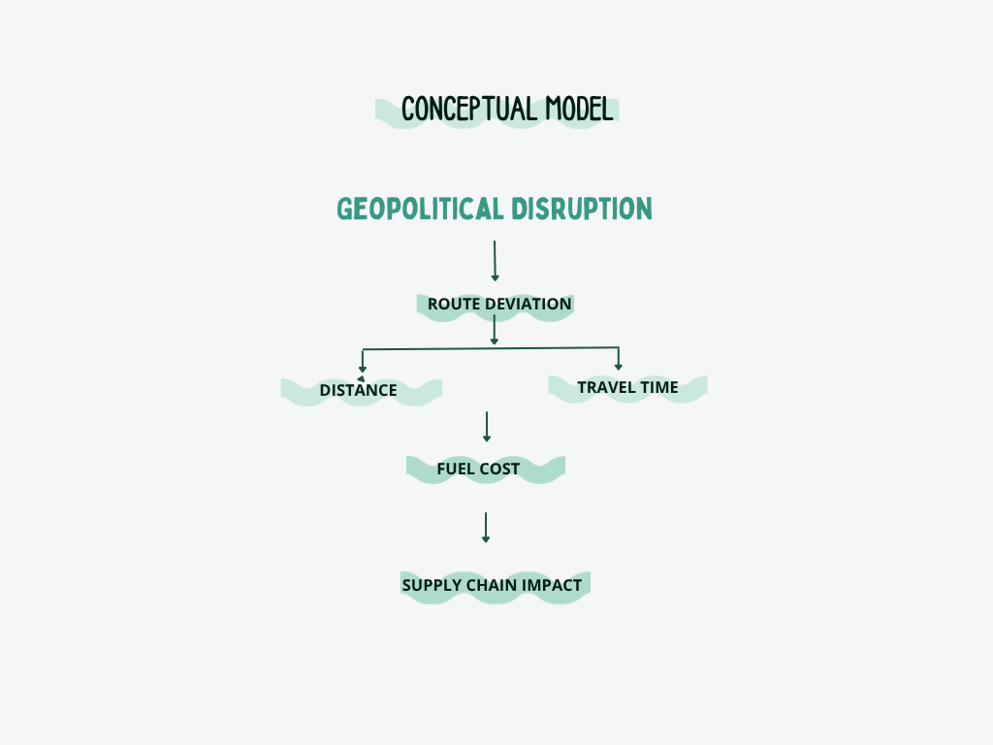

1. Data Sources
- AIS (Automatic Identification System) Dataset: Provided ship movement data, including MMSI, distances (dist_km), and estimated arrival times (ETA_hours).
- Port Activity Dataset: Offered contextual information on global trade flows and port operations.
- Fuel Dataset: Supplied current fuel price data for operational cost modeling and quantitative analysis.
2. Data Cleaning and Preparation
Raw datasets underwent systematic cleaning, including handling missing values, column selection, time format conversion, and creation of derived variables (e.g., Travel_Days). A unified final dataset was constructed with key columns: Ship_ID, Distance_km, ETA_hours, Travel_Days, Route_Type (Before/After), and Fuel_Cost. The prepared dataset was structured to support descriptive statistics, correlation analysis, regression modeling, and hypothesis testing.
3. Simulation Modeling
A scenario-based simulation was implemented to model the disruption:
- Before Scenario: Normal routing via the Strait of Hormuz (baseline distances and times).
- After Scenario: Rerouted path around the Cape of Good Hope.
Simulation adjustments included:
- Distance_km increased by a factor of 1.4 (reflecting real-world rerouting extensions).
- Travel_Days increased by +12 days on average.
This approach allowed estimation of impacts without relying solely on limited real-time proprietary crisis data (Walton R. B., 2019). The simulation structure aligns with the conceptual framework of the study, where geopolitical disruption leads to route deviation, increased travel distance, extended travel time, and higher operational fuel cost.

4. Analytical Techniques
• Descriptive Statistics & Visualization: Bar charts for comparing fuel cost and travel time; scatter plots with regression lines to examine distance-cost relationships (using Matplotlib).
• Correlation Analysis: Pearson correlation analysis was conducted to evaluate the statistical relationship between shipping distance and operational fuel cost.
• Inferential Statistics: Independent samples T-test to assess whether differences between “Before” and “After” scenarios were statistically significant (using SciPy).
• Regression Analysis: Linear regression to model the relationship Fuel_Cost = a × Distance + b (using Statsmodels).
• Geospatial Visualization: Interactive maps created with Folium to display normal (blue) vs. rerouted (red) paths.
5. Tools and Technologies
Python served as the core platform, supported by Pandas (data processing), NumPy (numerical operations), Matplotlib (visualization), SciPy & Statsmodels (correlation, hypothesis testing, and regression analysis).
Theoretical Framework
This research is grounded in several interconnected theories:
- Supply Chain Vulnerability and Resilience Theory — Recognizes that modern supply chains are complex, interconnected systems with critical nodes (chokepoints) whose disruption can propagate systemic risks. It emphasizes the need for redundancy, flexibility, and risk mitigation strategies (Verschuur , Lumma , & Hall ).
- Disruption Management and Simulation Theory — Simulation modeling is widely used in operations research to evaluate “what-if” scenarios when real-world experimentation is impractical or unethical. Discrete-event and scenario-based simulations effectively quantify the operational and economic impacts of maritime disruptions (Walton R. B., 2019).
- Geopolitical Risk in Global Trade — Frameworks linking geopolitical events to trade costs, route deviations, and economic spillovers. Chokepoint disruptions act as amplifiers of risk, affecting not just direct participants but global markets.
- Quantitative Logistics and Cost Modeling — Rooted in transportation economics, where distance, time, and fuel consumption are primary drivers of operational costs. Linear regression and statistical significance testing provide empirical validation of these relationships. Correlation and regression techniques are commonly used in quantitative logistics research to identify and validate relationships between operational variables such as distance, time, and transportation cost.
By integrating these theoretical lenses with practical data analysis and simulation, the study bridges academic concepts with real-world applicability, offering insights into how geopolitical shocks translate into measurable logistical and economic outcomes.

Chapter 4 –
4.1 Introduction
This chapter presents the findings obtained from the data analysis, simulation modeling, statistical testing, and geospatial visualization conducted in this study. The chapter analyzes the operational impact of shipping route disruption by comparing normal and rerouted shipping scenarios. Visualizations, statistical outputs, and mapping results are used to interpret the effect of route deviation on shipping distance, travel time, and fuel cost.
4.2 Data Preparation Results
Final Structured Dataset
After the data cleaning and transformation process, a final structured analytical dataset was created for simulation and statistical analysis. The dataset contained key operational variables related to maritime logistics, including shipping distance, estimated arrival time, travel duration, route category, and estimated fuel cost.
The variable “Route_Type” was used to distinguish between the normal shipping scenario (“Before”) and the simulated disrupted scenario (“After”). Additional variables such as “Travel_Days” and “Fuel_Cost” were calculated to support operational and economic analysis.
The final dataset enabled comparative analysis, visualization, hypothesis testing, regression modeling, and geospatial interpretation of shipping disruption impacts. The structured dataset also supported correlation analysis and predictive modeling to evaluate the statistical relationship between operational variables.
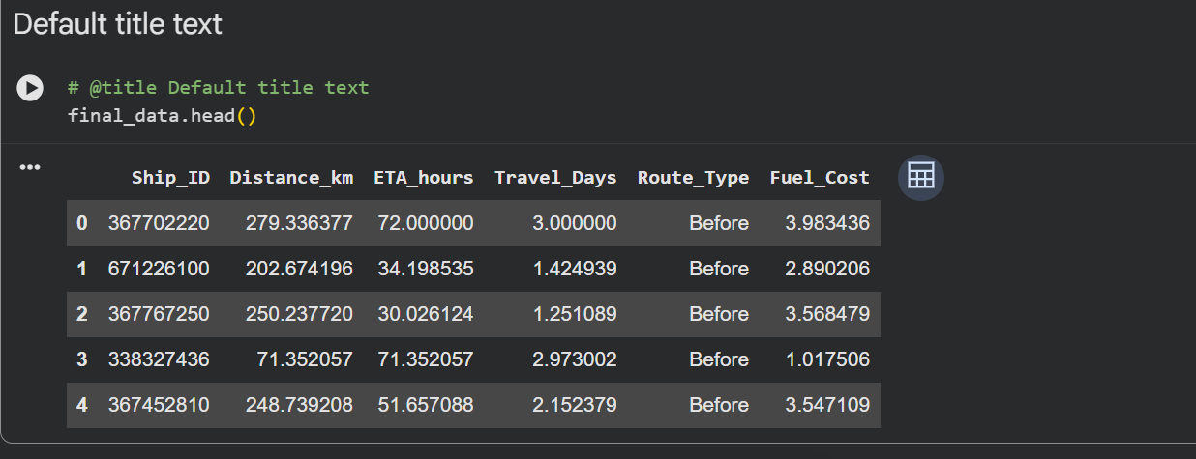
4.3 Descriptive Analysis & Visualization
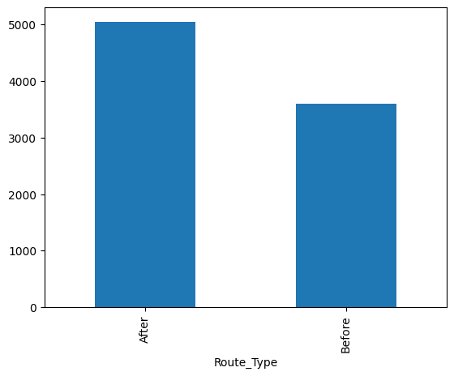
CHART 1 — Fuel Cost Comparison

Figure 1 Fuel Cost Comparison

The bar chart illustrates the difference in estimated operational fuel cost between the normal shipping route (“Before”) and the disrupted rerouted scenario (“After”). The findings indicate that the disrupted scenario experienced a significantly higher fuel cost compared to the normal route.
This increase is primarily associated with the extended shipping distance caused by rerouting around Africa following the simulated disruption in the Strait of Hormuz. The results demonstrate the economic impact of geopolitical instability on maritime transportation operations and supply chain expenses. This finding supports the assumption that geopolitical disruptions can substantially increase maritime operational expenses through route deviation and extended travel distance.

CHART 2 — Travel Time Comparison
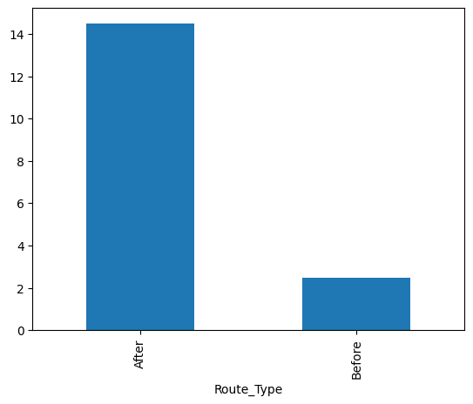
Figure 2 Travel Time Comparison

The visualization demonstrates a substantial increase in travel duration under the disrupted shipping scenario. Compared to the normal route, rerouted vessels required significantly more travel time due to the longer maritime path around Africa.
The findings highlight the operational consequences of route disruption on shipping efficiency and delivery performance. Increased travel duration may negatively affect supply chain coordination, inventory planning, and overall logistics reliability. The increased travel duration demonstrates how geopolitical instability can negatively affect shipping efficiency and supply chain responsiveness.

4.4 Correlation Analysis
Correlation analysis was conducted to evaluate the statistical relationship between shipping distance and operational fuel cost. The purpose of the analysis was to determine whether increases in travel distance were associated with increases in fuel expenditure within maritime logistics operations.
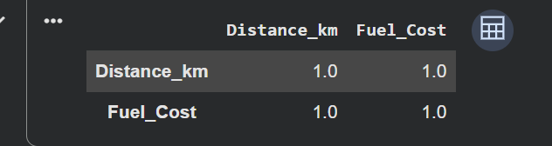
The correlation results indicated a strong positive relationship between shipping distance and fuel cost. This suggests that vessels traveling longer rerouted distances experienced significantly higher operational fuel expenses.
The findings support the conceptual framework of the study, where geopolitical disruption leads to route deviation, increased shipping distance, and higher operational cost. Therefore, the analysis confirms that operational fuel expenditure is strongly influenced by travel distance within disrupted shipping environments.

4.5 Hypothesis Testing
Hypothesis testing was conducted to determine whether the differences observed between the normal shipping scenario (“Before”) and the disrupted rerouted scenario (“After”) were statistically significant.
An independent sample T-test was applied to compare operational variables including fuel cost and travel time between the two scenarios.

The null hypothesis (H₀) stated that there was no significant difference between the normal and disrupted shipping scenarios. The alternative hypothesis (H₁) stated that a significant difference existed between the two scenarios.

The T-test results produced p-values below the significance threshold of 0.05 for both fuel cost and travel time. Since the p-values were significantly lower than 0.05, the null hypothesis was rejected.
Therefore, the findings confirm that geopolitical disruption had a statistically significant impact on maritime logistics operations by increasing operational fuel cost and travel duration.
Variable | P-value | Result
Fuel Cost | 0.000 | Significant
Travel Time | 0.000 | Significant

4.6 Regression Analysis
Scatter plot
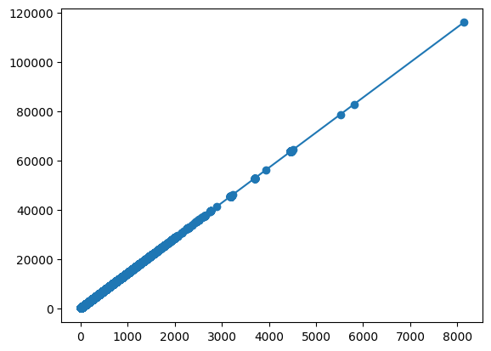
The scatter plot illustrates the relationship between shipping distance and operational fuel cost. Each point represents an individual shipping observation. The visualization shows a clear upward trend, indicating that fuel cost increases as shipping distance increases.
A regression line was added to the scatter plot to represent the overall trend in the data. The upward slope of the regression line demonstrates a positive linear relationship between shipping distance and fuel cost.

OLS Regression
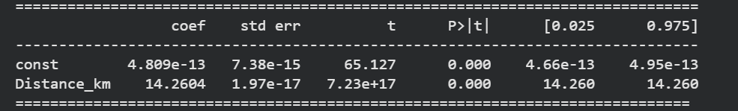
The regression analysis produced an R-squared value of 1.000, indicating a very strong relationship between shipping distance and fuel cost. The coefficient value of 14.2604 suggests that fuel cost increases proportionally with distance. Furthermore, the statistical significance value (p < 0.05) confirms that the relationship is statistically significant.

4.6 Geospatial Mapping Findings
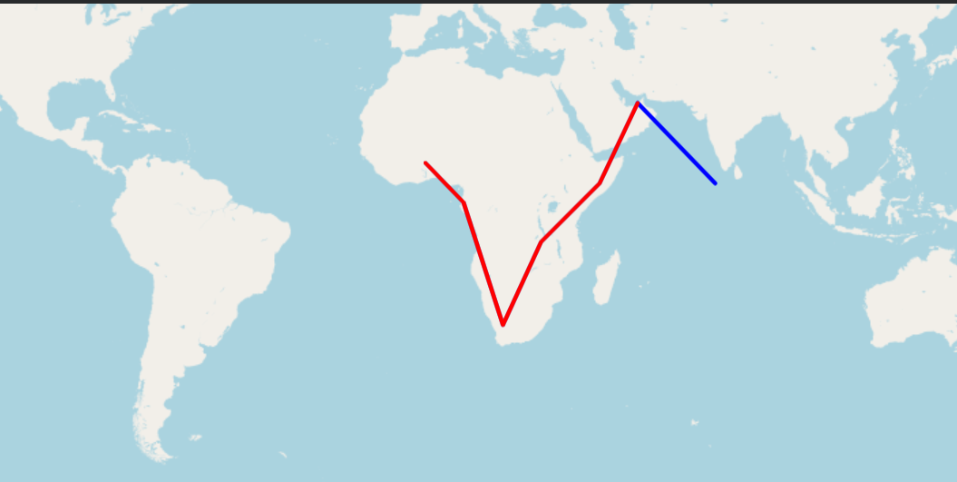

Geospatial visualization was used to illustrate the difference between the normal shipping route and the disrupted rerouted path. A Folium-based map was developed to visually compare the operational changes caused by geopolitical disruption in the Strait of Hormuz.
The blue route represents the normal maritime path through the Strait of Hormuz and surrounding trade corridors. The red route represents the simulated disrupted scenario, where vessels were rerouted around the African coastline due to restricted access to the original route.
The visualization clearly demonstrates the significant increase in travel distance associated with rerouting. Compared to the normal route, the disrupted path requires a substantially longer maritime journey, resulting in increased travel time and operational fuel cost.
The geospatial findings support the statistical and regression analysis results presented earlier in this chapter. The map provides a visual representation of how geopolitical disruption can alter global shipping patterns and create operational challenges within maritime logistics and supply chain systems.
4.7 Summary of Findings
The findings of this study demonstrate that geopolitical disruption significantly affects maritime logistics operations. Comparative analysis showed that rerouted shipping scenarios experienced higher fuel costs and longer travel durations compared to normal shipping routes.
Statistical testing confirmed that these differences were statistically significant, while regression analysis revealed a strong positive relationship between shipping distance and operational fuel cost. Furthermore, geospatial visualization highlighted the scale of route deviation caused by disruption in the Strait of Hormuz.
Overall, the results indicate that geopolitical instability can create substantial operational and economic consequences for global shipping and supply chain systems.

Discussion of Findings & Conclusion
Introduction
This chapter discusses the findings obtained from the quantitative analysis conducted in this study and interprets their significance within the context of maritime logistics and geopolitical disruption. The discussion connects descriptive statistics, correlation analysis, hypothesis testing, regression analysis, and geospatial visualization findings to the research objectives and conceptual framework of the study. The chapter also outlines the practical implications of the research, study limitations, recommendations for future research, and the overall conclusion.
Finding 1 — Fuel Cost Increase
The findings revealed that the disrupted shipping scenario resulted in significantly higher operational fuel costs compared to the normal route. This increase was primarily caused by the extended travel distance associated with rerouting around Africa. The results highlight the economic vulnerability of maritime logistics systems to geopolitical instability and demonstrate how route disruption can directly increase transportation expenses. The findings further confirm that operational fuel expenditure is highly sensitive to changes in shipping distance during disruption scenarios.
Finding 2 — Travel Time Increase
The analysis also demonstrated a substantial increase in travel duration under the disrupted scenario. Longer delivery times reduce supply chain efficiency and may negatively affect inventory management, production scheduling, and customer service reliability. These findings emphasize the importance of resilient logistics planning during periods of geopolitical uncertainty.These operational delays may also contribute to increased freight congestion, inventory shortages, and reduced responsiveness across international supply chain networks.

Finding 3 — Correlation and Statistical Significance
Correlation analysis identified a strong positive relationship between shipping distance and operational fuel cost, indicating that increased travel distance was directly associated with higher transportation expenses.
The T-test results confirmed that the differences between the normal and disrupted shipping scenarios were statistically significant. Since the p-values were below the significance threshold of 0.05, the study was able to reject the null hypothesis and validate that geopolitical disruption had a measurable operational impact on maritime logistics.

Finding 4 — Regression Relationship
Regression analysis revealed a strong positive relationship between shipping distance and operational fuel cost. The regression model demonstrated that increases in travel distance correspond directly to higher operational expenses. This finding supports the assumption that rerouted shipping paths contribute significantly to transportation cost escalation. The regression model also demonstrated the practical value of predictive analytics techniques in estimating operational costs within disrupted maritime logistics environments.
Finding 5 — Geospatial Mapping
The geospatial visualization provided a clear representation of the scale of route deviation caused by disruption in the Strait of Hormuz. The mapping results demonstrated how localized geopolitical events can alter global shipping patterns and create substantial logistical challenges for international trade systems. The visualization also demonstrated the importance of GIS-based analytical tools in supporting strategic logistics planning and maritime risk assessment.
5.3 Implications of the Study
The findings of this research have important implications for shipping companies, logistics providers, supply chain managers, and policymakers. The study demonstrates how geopolitical disruptions can increase operational cost and reduce transportation efficiency within global maritime trade systems.
The results highlight the importance of contingency planning, route diversification, and supply chain resilience strategies in minimizing the impact of future disruptions. Additionally, the research illustrates how data analytics and simulation modeling can support evidence-based decision-making in logistics and transportation management. From a Business Information Systems perspective, the study demonstrates how quantitative analytics, simulation modeling, and geospatial technologies can be integrated to support operational decision-making in complex logistics environments. The findings emphasize the growing importance of data-driven risk management strategies within global transportation and supply chain systems.
5.4 Limitations of the Study
This study was primarily based on simulation modeling rather than real-time geopolitical disruption data. Due to the limited availability of operational shipping data during actual conflict scenarios, certain assumptions were applied when creating the disrupted shipping environment.
Additionally, the study focused mainly on operational variables such as distance, travel time, and fuel cost, while other external factors such as weather conditions, port congestion, and insurance premiums were not included in the analysis. Therefore, the findings should be interpreted as estimated operational impacts rather than exact real-world measurements.
5.5 Recommendations for Future Research
Future research could incorporate real-time maritime traffic data and broader operational variables such as insurance cost, cargo delay penalties, and environmental impact. Further studies may also compare multiple geopolitical chokepoints and evaluate disruption patterns across different global trade regions.
Additionally, machine learning and predictive analytics techniques could be applied to improve disruption forecasting and supply chain risk management. Future studies may also integrate artificial intelligence and real-time maritime analytics platforms to improve predictive disruption monitoring and operational optimization.
5.6 Conclusion
This study analyzed the operational impact of geopolitical disruption on maritime logistics using simulation modeling, statistical analysis, regression modeling, and geospatial visualization techniques. The findings demonstrated that rerouted shipping scenarios significantly increased travel distance, delivery time, and operational fuel cost.
Statistical testing confirmed that these differences were significant, while regression analysis identified a strong positive relationship between shipping distance and fuel cost. Geospatial mapping further illustrates the scale of route deviation caused by disruption in the Strait of Hormuz.
Overall, the study highlights the vulnerability of global supply chain systems to geopolitical instability and demonstrates the value of data-driven analysis in supporting logistics planning and operational decision-making.
The study successfully demonstrates how quantitative analytical frameworks can be applied to evaluate geopolitical disruption within maritime logistics systems. By integrating simulation modeling, statistical validation, and geospatial visualization, the research provides a practical and data-driven approach for understanding supply chain vulnerability and operational risk in global trade environments.

Appendix
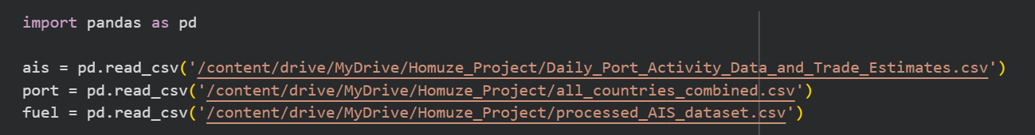
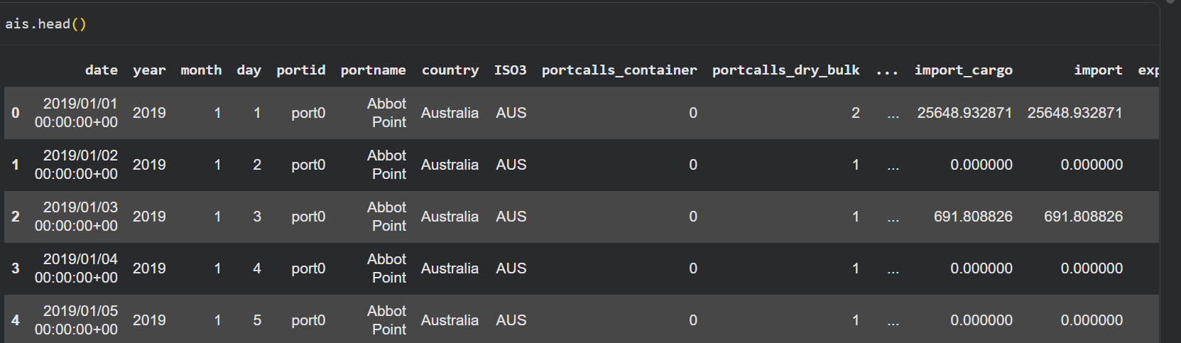
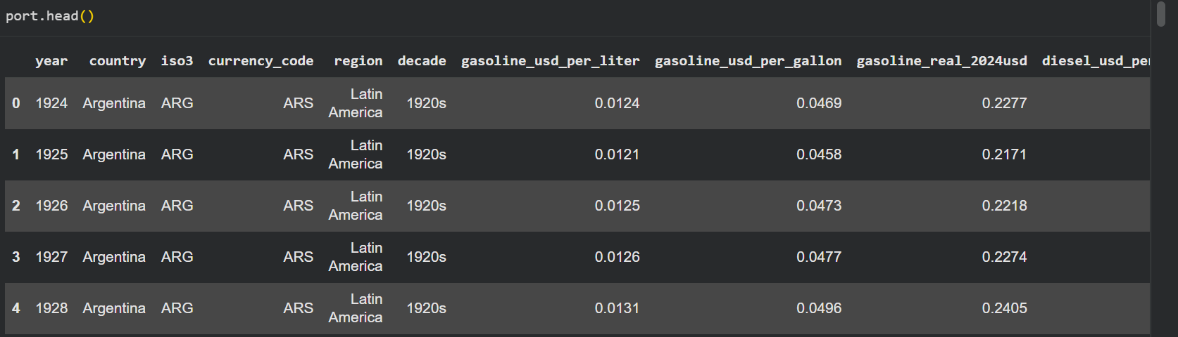
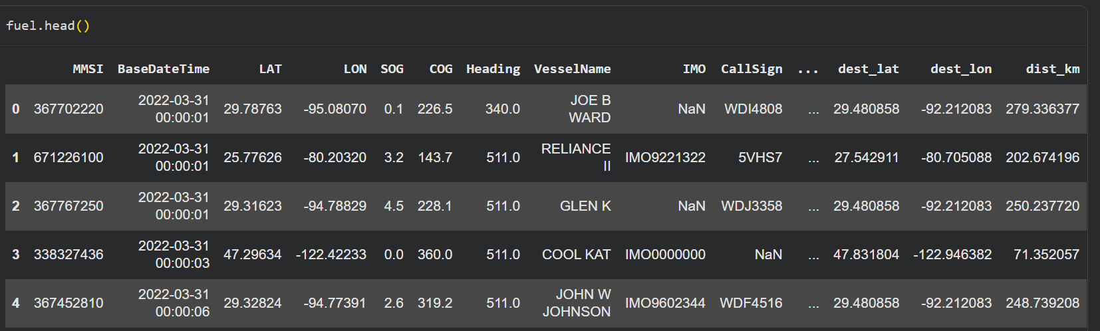
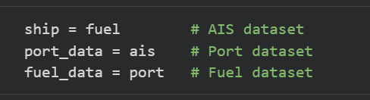
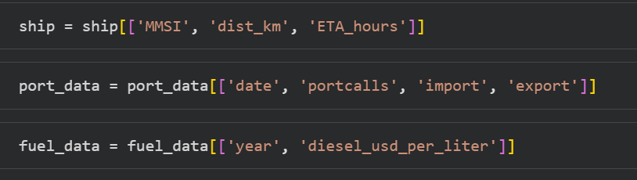
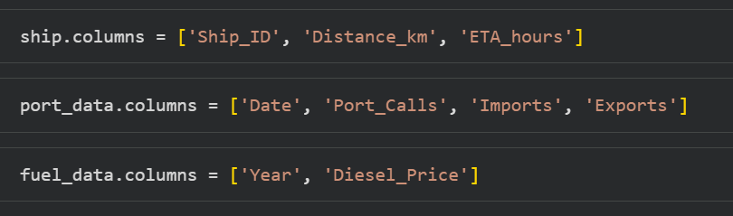
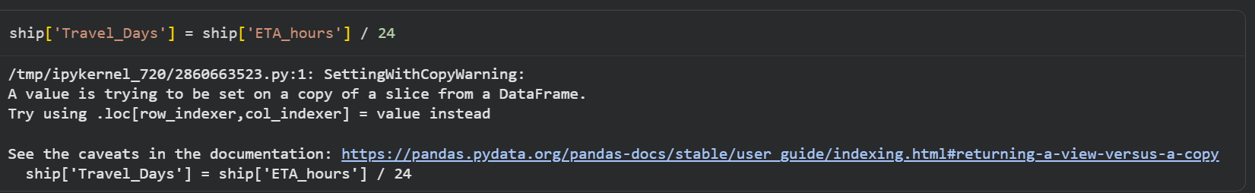
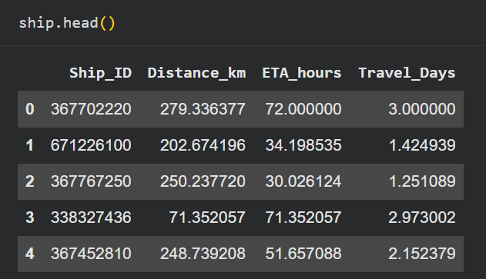
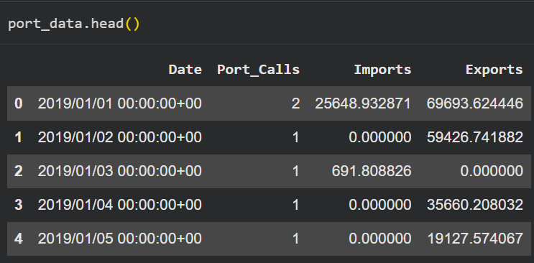
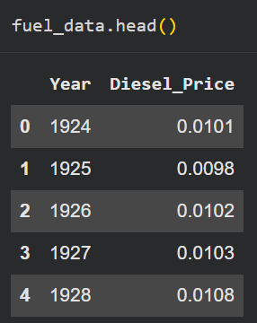
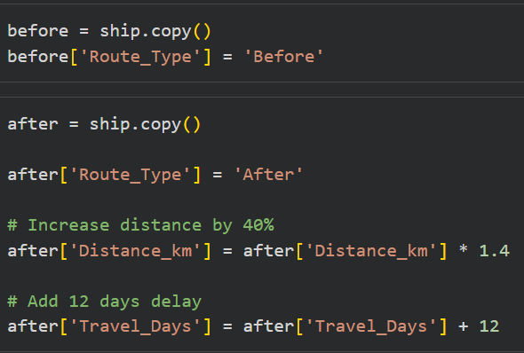

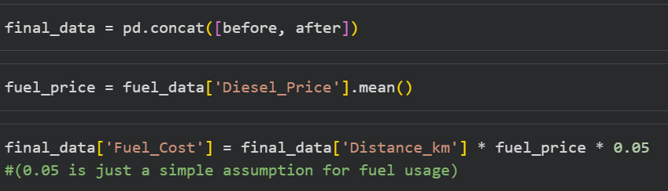
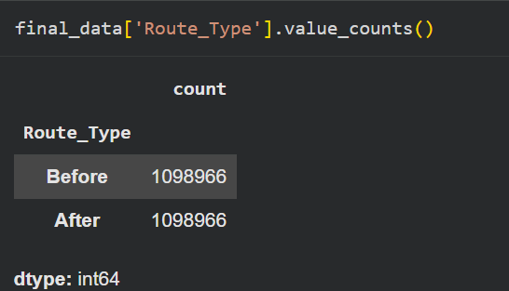

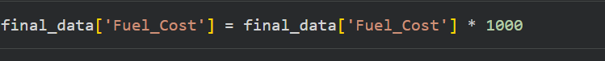
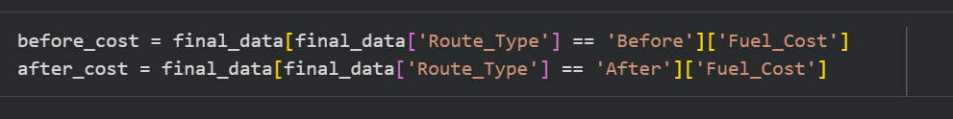
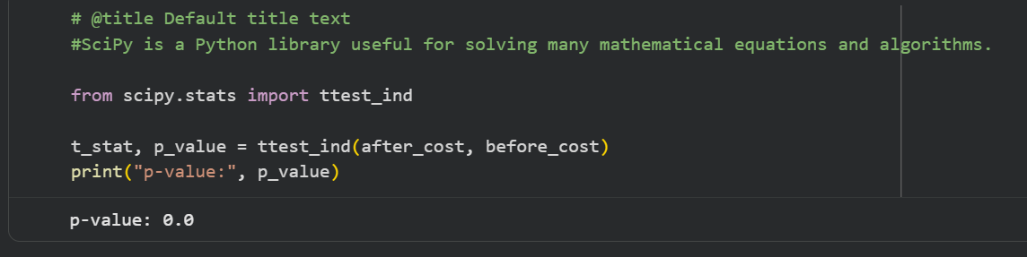
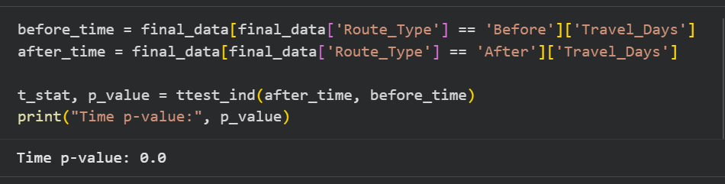

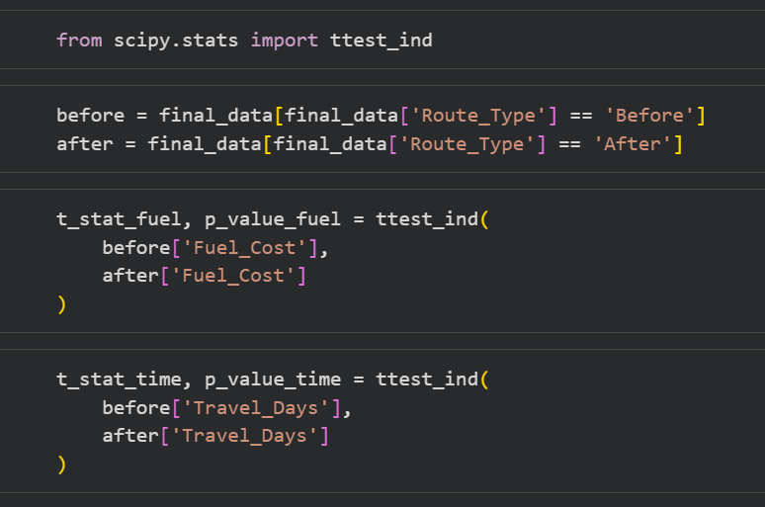

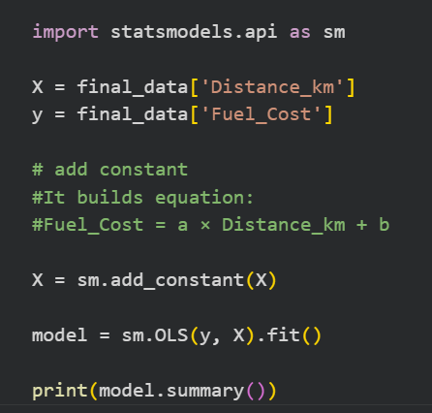

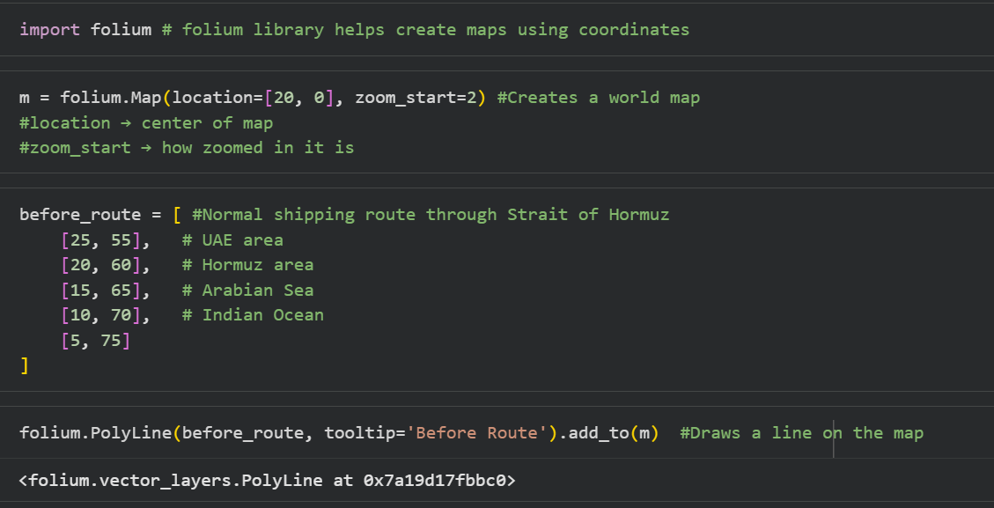
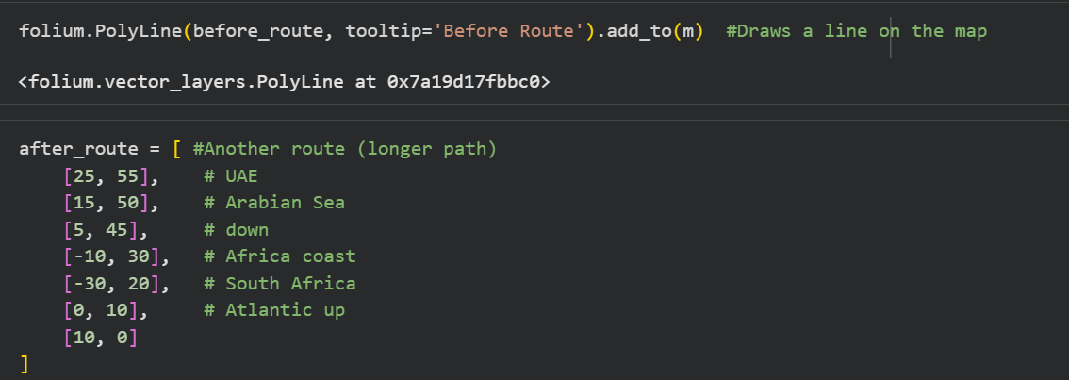
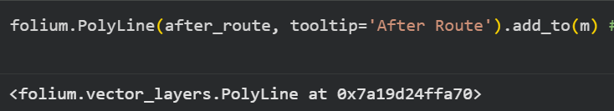
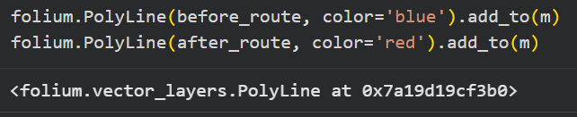

Bibliography

References
Lumma, D., Verschuur, D., & Hall, P. j. (2026, March 04). Shipping disruptions at maritime chokepoints highlight growing global trade risks.
air7seas. (n.d.). Cape of Good Hope Rerouting: What It Means for Your Transit Times and Costs. Retrieved from air7seas: https://air7seas.com/blog/cape-of-good-hope-rerouting-what-it-means-for-your-transit-times-and-costs
Arvis, J. F., & Rodrigue , J. P. (2026, February). article. Retrieved from sciencedirect: https://www.sciencedirect.com/science/article/pii/S0966692326000293
Attinasi, M. G., & Boeckelmann, L. (n.d.). Sailing through storms: The fallout of Red Sea disruptions for global trade and inflation. Retrieved from cepr: https://cepr.org/voxeu/columns/sailing-through-storms-fallout-red-sea-disruptions-global-trade-and-inflation
Balasubramanian, P., & Soman, S. (2025). GEOPOLITICAL RISKS IN MARITIME SHIPPING: CHALLENGES AND STRATEGIC ADAPTATIONS FOR PRIMARY CHOKEPOINTS. , Amrita Schoo, Commerce and Management. Retrieved from https://lex-localis.org/index.php/LexLocalis/article/view/801897/2283
Conte, N. (2026, March 3). charted-oil-trade-through-the-strait-of-hormuz-by-country. Retrieved from visualcapitalist: https://www.visualcapitalist.com/charted-oil-trade-through-the-strait-of-hormuz-by-country/
del Castillo, P. G., & Çetin, S. (2026, Apr 29 ). maritime-chokepoints-strategic-vulnerabilities-in-global-trade. Retrieved from atradius: https://atradius.gr/knowledge-and-research/resources/maritime-chokepoints-strategic-vulnerabilities-in-global-trade
Dunn, C., & Barden, J. (2023, November 21). Today in Energy. Retrieved from eia: https://www.eia.gov/todayinenergy/detail.php?id=61002#
eia. (2026, March 3). World_Oil_Transit_Chokepoints. Retrieved from eia: https://www.eia.gov/international/analysis/special-topics/World_Oil_Transit_Chokepoints
Fortino, K. (2026, Mar 02). Strait of Hormuz Disruption Impacts Global Logistics and Freight Networks. Retrieved from customssupport: https://www.customssupport.com/strait-of-hormuz-impacts-global-logistics-and-freight-networks/
Georgoulas, D. (2026, june 19). article. Retrieved from sciencedirect: https://www.sciencedirect.com/science/article/pii/S2772390926000259
Globe, C. (2026, May 8). Strait of Hormuz closure 2026. Retrieved from carraglobe: https://carraglobe.com/strait-of-hormuz-closure-2026/
iea. ( 2026, February ). strait-of-hormuz. Retrieved from iea: https://www.iea.org/about/oil-security-and-emergency-response/strait-of-hormuz
IM, Y. (2026). Quantifying Maritime Chokepoint Disruptions Using AIS Data.
loghub. (2026, March 26). Strait of Hormuz Closure: Supply Chain Impact. Retrieved from log-hub: https://log-hub.com/strait-of-hormuz-closure-supply-chain-impact/
loghub. (2026, March 26). strait-of-hormuz-closure-supply-chain-impact. Retrieved from log-hub: https://log-hub.com/strait-of-hormuz-closure-supply-chain-impact/
Mashange, G. (2026). The Strait of Hormuz: Why Global Trade Dependency Turns a Localized Conflict into a Global Crisis. University of Illinois, Agricultural and Consumer Economics. Retrieved from https://farmdocdaily.illinois.edu/2026/03/the-strait-of-hormuz-why-global-trade-dependency-turns-a-localized-conflict-into-a-global-crisis.html
Medem, R. (n.d.). hormuz-strait-closed. Retrieved from neurored: https://www.neurored.com/blog/hormuz-strait-closed/
Okebiorun, O. (2026, May 05). Retrieved from businessinsider Africa: https://africa.businessinsider.com/local/markets/south-africa-misses-out-on-billions-in-shipping-revenue-as-strait-of-hormuz/ycmylm7
Okebiorun, O. (2026, May 05). Strait of Hormuz disruption drives Cape of Good Hope traffic surge. Retrieved from https://africa.businessinsider.com/local/markets/south-africa-misses-out-on-billions-in-shipping-revenue-as-strait-of-hormuz/ycmylm7
Paladinou , G. (2025). The Geopolitical Importance of Maritime Choke. Internationa & Euproian studies. Retrieved from https://dione.lib.unipi.gr/xmlui/bitstream/handle/unipi/18812/Paladinou_men22029.pdf?sequence=1&isAllowed=y
publication. (n.d.). Retrieved from unctad: https://unctad.org/publication/strait-hormuz-disruptions-implications-global-trade-and-development
Qu, S., & Wei , Y. M. (2024, July 1). article. Retrieved from sciencedirect: https://www.sciencedirect.com/science/article/pii/S2666675824000912
Rasmussen , L., & Ghosh, K. (2026, March 1). Shipping companies divert vessels around Cape of Good Hope after strikes on Iran. Retrieved from reuters: https://www.reuters.com/world/middle-east/maersk-pauses-sailings-through-suez-canal-bab-el-mandeb-strait-citing-escalating-2026-03-01/
shokri, U. (2026, March 3). Global Markets and the Strait of Hormuz: The Economic Shockwaves of the Iran War. Retrieved from stimson: https://www.stimson.org/2026/global-markets-and-the-strait-of-hormuz-the-economic-shockwaves-of-the-iran-war/
Soman, S., & P. Balasubramanian. (2025). GEOPOLITICAL RISKS IN MARITIME SHIPPING: CHALLENGES AND STRATEGIC ADAPTATIONS FOR PRIMARY CHOKEPOINTS. Amrita School, Commerce and Management, Kerala. doi:10.52152/801897
Strait of Hormuz. (n.d.). Retrieved from iea: http://iea.org/about/oil-security-and-emergency-response/strait-of-hormuz
Ulrichsen, K. C. (2026 , March 16 ). Maritime Chokepoints and Risks to Global Shipping and Energy Security. Retrieved from bakerinstitute: https://www.bakerinstitute.org/research/maritime-chokepoints-and-risks-global-shipping-and-energy-security
unctad. (2024, February). Impact to Global Trade of Disruption of Shipping Routes in the Red Sea, Black Sea and Panama Canal. Retrieved from unctad: https://unctad.org/publication/navigating-troubled-waters-impact-global-trade-disruption-shipping-routes-red-sea-black
unctad. (2024). Vulnerability of supply chains exposed as global maritime chokepoints come under pressure. Retrieved from unctad: https://unctad.org/press-material/vulnerability-supply-chains-exposed-global-maritime-chokepoints-come-under-pressure
UNCTAD. (2026). Strait of Hormuz disruptions: Implications for global trade and development. UNCTAD. Retrieved from https://unctad.org/publication/strait-hormuz-disruptions-implications-global-trade-and-development
Verschuur , J., Lumma , J., & Hall , J. W. (n.d.). Systemic impacts of disruptions at maritime chokepoints. doi:10.1038/s41467-025-65403-w
Walton , R. B. (2019). Simulating Maritime Chokepoint Disruption in the Global Food Supply. Air Force Institute of Technology, AIR FORCE. scholar. Retrieved from https://scholar.afit.edu/cgi/viewcontent.cgi?article=3320&context=etd
Walton, R. B. (2019). SIMULATING MARITIME CHOKEPOINT DISRUPTION IN THE GLOBAL FOOD SUPPLY. AIR UNIVERSITY, AIR FORCE. Retrieved from https://apps.dtic.mil/sti/trecms/pdf/AD1077568.pdf
Walton, R., Miller, J., & Champagne, L. (2019). Simulation Maritime Chokepoint Disruption in the Global Food Supply. Retrieved from simio: https://www.simio.com/case-studies/simulation-maritime-chokepoint-disruption-in-the-global-food-supply
wtop. (2026, March 19). The Strait of Hormuz has a long history of disruption. Retrieved from wtop: https://wtop.com/national/2026/03/the-strait-of-hormuz-has-been-disrupted-before-a-look-at-past-moments-that-threatened-oil-flows/

Lumma, D., Verschuur, D., & Hall, P. j. (2026, March 04). Shipping disruptions at maritime chokepoints highlight growing global trade risks.
air7seas. (n.d.). Cape of Good Hope Rerouting: What It Means for Your Transit Times and Costs. Retrieved from air7seas: https://air7seas.com/blog/cape-of-good-hope-rerouting-what-it-means-for-your-transit-times-and-costs
Arvis, J. F., & Rodrigue , J. P. (2026, February). article. Retrieved from sciencedirect: https://www.sciencedirect.com/science/article/pii/S0966692326000293
Attinasi, M. G., & Boeckelmann, L. (n.d.). Sailing through storms: The fallout of Red Sea disruptions for global trade and inflation. Retrieved from cepr: https://cepr.org/voxeu/columns/sailing-through-storms-fallout-red-sea-disruptions-global-trade-and-inflation
Balasubramanian, P., & Soman, S. (2025). GEOPOLITICAL RISKS IN MARITIME SHIPPING: CHALLENGES AND STRATEGIC ADAPTATIONS FOR PRIMARY CHOKEPOINTS. , Amrita Schoo, Commerce and Management. Retrieved from https://lex-localis.org/index.php/LexLocalis/article/view/801897/2283
Conte, N. (2026, March 3). charted-oil-trade-through-the-strait-of-hormuz-by-country. Retrieved from visualcapitalist: https://www.visualcapitalist.com/charted-oil-trade-through-the-strait-of-hormuz-by-country/
del Castillo, P. G., & Çetin, S. (2026, Apr 29 ). maritime-chokepoints-strategic-vulnerabilities-in-global-trade. Retrieved from atradius: https://atradius.gr/knowledge-and-research/resources/maritime-chokepoints-strategic-vulnerabilities-in-global-trade
Dunn, C., & Barden, J. (2023, November 21). Today in Energy. Retrieved from eia: https://www.eia.gov/todayinenergy/detail.php?id=61002#
eia. (2026, March 3). World_Oil_Transit_Chokepoints. Retrieved from eia: https://www.eia.gov/international/analysis/special-topics/World_Oil_Transit_Chokepoints
Fortino, K. (2026, Mar 02). Strait of Hormuz Disruption Impacts Global Logistics and Freight Networks. Retrieved from customssupport: https://www.customssupport.com/strait-of-hormuz-impacts-global-logistics-and-freight-networks/
Georgoulas, D. (2026, june 19). article. Retrieved from sciencedirect: https://www.sciencedirect.com/science/article/pii/S2772390926000259
Globe, C. (2026, May 8). Strait of Hormuz closure 2026. Retrieved from carraglobe: https://carraglobe.com/strait-of-hormuz-closure-2026/
iea. ( 2026, February ). strait-of-hormuz. Retrieved from iea: https://www.iea.org/about/oil-security-and-emergency-response/strait-of-hormuz
IM, Y. (2026). Quantifying Maritime Chokepoint Disruptions Using AIS Data.
loghub. (2026, March 26). Strait of Hormuz Closure: Supply Chain Impact. Retrieved from log-hub: https://log-hub.com/strait-of-hormuz-closure-supply-chain-impact/
loghub. (2026, March 26). strait-of-hormuz-closure-supply-chain-impact. Retrieved from log-hub: https://log-hub.com/strait-of-hormuz-closure-supply-chain-impact/
Mashange, G. (2026). The Strait of Hormuz: Why Global Trade Dependency Turns a Localized Conflict into a Global Crisis. University of Illinois, Agricultural and Consumer Economics. Retrieved from https://farmdocdaily.illinois.edu/2026/03/the-strait-of-hormuz-why-global-trade-dependency-turns-a-localized-conflict-into-a-global-crisis.html
Medem, R. (n.d.). hormuz-strait-closed. Retrieved from neurored: https://www.neurored.com/blog/hormuz-strait-closed/
Okebiorun, O. (2026, May 05). Retrieved from businessinsider Africa: https://africa.businessinsider.com/local/markets/south-africa-misses-out-on-billions-in-shipping-revenue-as-strait-of-hormuz/ycmylm7
Okebiorun, O. (2026, May 05). Strait of Hormuz disruption drives Cape of Good Hope traffic surge. Retrieved from https://africa.businessinsider.com/local/markets/south-africa-misses-out-on-billions-in-shipping-revenue-as-strait-of-hormuz/ycmylm7
Paladinou , G. (2025). The Geopolitical Importance of Maritime Choke. Internationa & Euproian studies. Retrieved from https://dione.lib.unipi.gr/xmlui/bitstream/handle/unipi/18812/Paladinou_men22029.pdf?sequence=1&isAllowed=y
publication. (n.d.). Retrieved from unctad: https://unctad.org/publication/strait-hormuz-disruptions-implications-global-trade-and-development
Qu, S., & Wei , Y. M. (2024, July 1). article. Retrieved from sciencedirect: https://www.sciencedirect.com/science/article/pii/S2666675824000912
Rasmussen , L., & Ghosh, K. (2026, March 1). Shipping companies divert vessels around Cape of Good Hope after strikes on Iran. Retrieved from reuters: https://www.reuters.com/world/middle-east/maersk-pauses-sailings-through-suez-canal-bab-el-mandeb-strait-citing-escalating-2026-03-01/
shokri, U. (2026, March 3). Global Markets and the Strait of Hormuz: The Economic Shockwaves of the Iran War. Retrieved from stimson: https://www.stimson.org/2026/global-markets-and-the-strait-of-hormuz-the-economic-shockwaves-of-the-iran-war/
Soman, S., & P. Balasubramanian. (2025). GEOPOLITICAL RISKS IN MARITIME SHIPPING: CHALLENGES AND STRATEGIC ADAPTATIONS FOR PRIMARY CHOKEPOINTS. Amrita School, Commerce and Management, Kerala. doi:10.52152/801897
Strait of Hormuz. (n.d.). Retrieved from iea: http://iea.org/about/oil-security-and-emergency-response/strait-of-hormuz
Ulrichsen, K. C. (2026 , March 16 ). Maritime Chokepoints and Risks to Global Shipping and Energy Security. Retrieved from bakerinstitute: https://www.bakerinstitute.org/research/maritime-chokepoints-and-risks-global-shipping-and-energy-security
unctad. (2024, February). Impact to Global Trade of Disruption of Shipping Routes in the Red Sea, Black Sea and Panama Canal. Retrieved from unctad: https://unctad.org/publication/navigating-troubled-waters-impact-global-trade-disruption-shipping-routes-red-sea-black
unctad. (2024). Vulnerability of supply chains exposed as global maritime chokepoints come under pressure. Retrieved from unctad: https://unctad.org/press-material/vulnerability-supply-chains-exposed-global-maritime-chokepoints-come-under-pressure
UNCTAD. (2026). Strait of Hormuz disruptions: Implications for global trade and development. UNCTAD. Retrieved from https://unctad.org/publication/strait-hormuz-disruptions-implications-global-trade-and-development
Verschuur , J., Lumma , J., & Hall , J. W. (n.d.). Systemic impacts of disruptions at maritime chokepoints. doi:10.1038/s41467-025-65403-w
Walton , R. B. (2019). Simulating Maritime Chokepoint Disruption in the Global Food Supply. Air Force Institute of Technology, AIR FORCE. scholar. Retrieved from https://scholar.afit.edu/cgi/viewcontent.cgi?article=3320&context=etd
Walton, R. B. (2019). SIMULATING MARITIME CHOKEPOINT DISRUPTION IN THE GLOBAL FOOD SUPPLY. AIR UNIVERSITY, AIR FORCE. Retrieved from https://apps.dtic.mil/sti/trecms/pdf/AD1077568.pdf
Walton, R., Miller, J., & Champagne, L. (2019). Simulation Maritime Chokepoint Disruption in the Global Food Supply. Retrieved from simio: https://www.simio.com/case-studies/simulation-maritime-chokepoint-disruption-in-the-global-food-supply
wtop. (2026, March 19). The Strait of Hormuz has a long history of disruption. Retrieved from wtop: https://wtop.com/national/2026/03/the-strait-of-hormuz-has-been-disrupted-before-a-look-at-past-moments-that-threatened-oil-flows/

